Dear students and parents,

I am so excited that I get to teach Math 7 and Secondary Math 1 this year at Arches!
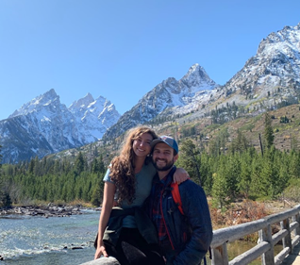
The principles and skills that we will tackle together this year will build on the foundations of previous years and prepare them to excel in their future classes and mathematical pursuits. Some kids feel like math they learn in school is pointless, but we will discover how math is part of every part of life, from the structures we live in to the sports we play. I strongly believe that no one is destined to be “not a math person” and when we start to see math in the world around us, it becomes much easier to embrace math in the classroom. We will foster a can-do attitude in our math classes!
I could not get enough of math when I was in school. That is not to say that everything in my classes came easily to me—it was sometimes a real struggle to “get it”! But I found that when I diligently tried to understand the properties of numbers and equations, I was reliably rewarded with aha moments. Learning how to learn math led me to become a math tutor and teach at Mathnasium centers. There, I loved helping kids who had yet to realize they could do math, as well as challenging the kids who were itching to improve even more. Another thing that helped me translate the struggle into joyful success in math was passionate teachers. It is my hope that I can nurture (or spark) a love for math in my students this year.
Whenever I can, I love to adventure in the mountains with my husband. Whether skiing through the snow, hiking through the trails, or paragliding through the wind, we love to be in the mountains! I also enjoy gardening, reading, and doing family history research. In fact, I have teaching in my blood; many of my ancestors were teachers. I feel grateful to join a long lineage of teachers.

I cannot wait to get math-ing!
Mrs. Bjork

